Project Plan3

Mobile Application Development (Fall 2015)

Instructor: Alieen Pierce

To start off the application that uses OpenCV (Open Computer Vision) library and Manager, I will develop the basic camera application that allows the device to access to the camera and read the frame rate what it sees. As importing java wrapper library for OpenCV which is codded in C/C++ and the environment setup are hard themselves, I would not to much be ambitious to do complicated things, but as time allows, I hope to enable one simple object detection algorithm upon device camera.

Since the simplest object detection used in wide range of application with OpenCV is area differentiation using color set, I will develop the plug-in to detect color sets, that are collective colors similar compared to the other color set. When a specific color is selected by tapping from the screen, the application will automatically disable other colors to define selected color as same objects.

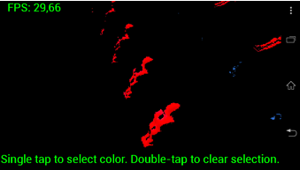

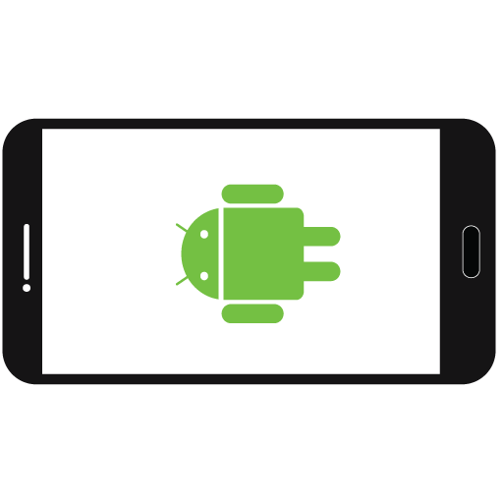

Resources:

* OpenCV official Site <http://opencv.org/>
* SourceForge (latest OpenCV java wrapper libraries) <http://sourceforge.net/projects/opencvlibrary/files/opencv-android/3.0.0>
* OpenCV colorblob detection <https://github.com/Itseez/opencv/tree/master/samples/android/color-blob-detection>
* Sonymobile Android developer tutorial <http://developer.sonymobile.com/knowledge-base/tutorials/android_tutorial/get-started-with-opencv-on-android/>